MEMBERSHIP MANAGEMENT SYSTEM
@CREATIVITY THINK (9483175986/7019689991)

ABSTRACT:
Membership Management System is a web application designed to streamline membership operations for clubs, gyms, and organizations. Users can add and manage profiles, make payments, receive renewal reminders, and track activity via dashboards. Administrators manage members, monitor payments and renewals, and generate analytics dashboards. Built using Django, Django Rest Framework, React, Axios, and Recharts, this platform simplifies membership tracking, payment management, and reporting..

INTRODUCTION OF THE PROJECT:
Managing memberships manually is prone to errors and inefficiencies. This system provides an intuitive platform to handle member profiles, track payments, send renewal reminders, and monitor membership activity through dashboards. Administrators can manage payments, renewals, and view analytics to ensure smooth operation of membership-based organizations..

PROJECT OBJECTIVES:

• Digitize membership management and payment tracking
• Allow users to add profiles and make payments online
• Send renewal reminders automatically
• Provide dashboards for tracking membership activity
• Enable administrators to monitor renewals and payments
• Generate analytics for decision-making
• Reduce errors and manual workload
• Support efficient membership operations

PROBLEM OF THE STATEMENT:
Manual membership tracking is inefficient, prone to errors, and lacks real-time visibility into payments and renewals. Membership Management System addresses these issues by providing a web-based solution for tracking profiles, payments, renewal reminders, and administrative analytics..

MOTIVATION OF THE PROJECT:
• Automate membership management and payments
• Provide instant visibility on member renewals and dues
• Reduce manual record-keeping and errors
• Improve operational efficiency for clubs and gyms
• Enable data-driven decisions with dashboard analytics

BLOCK DAIGRAM OF PROJECT:

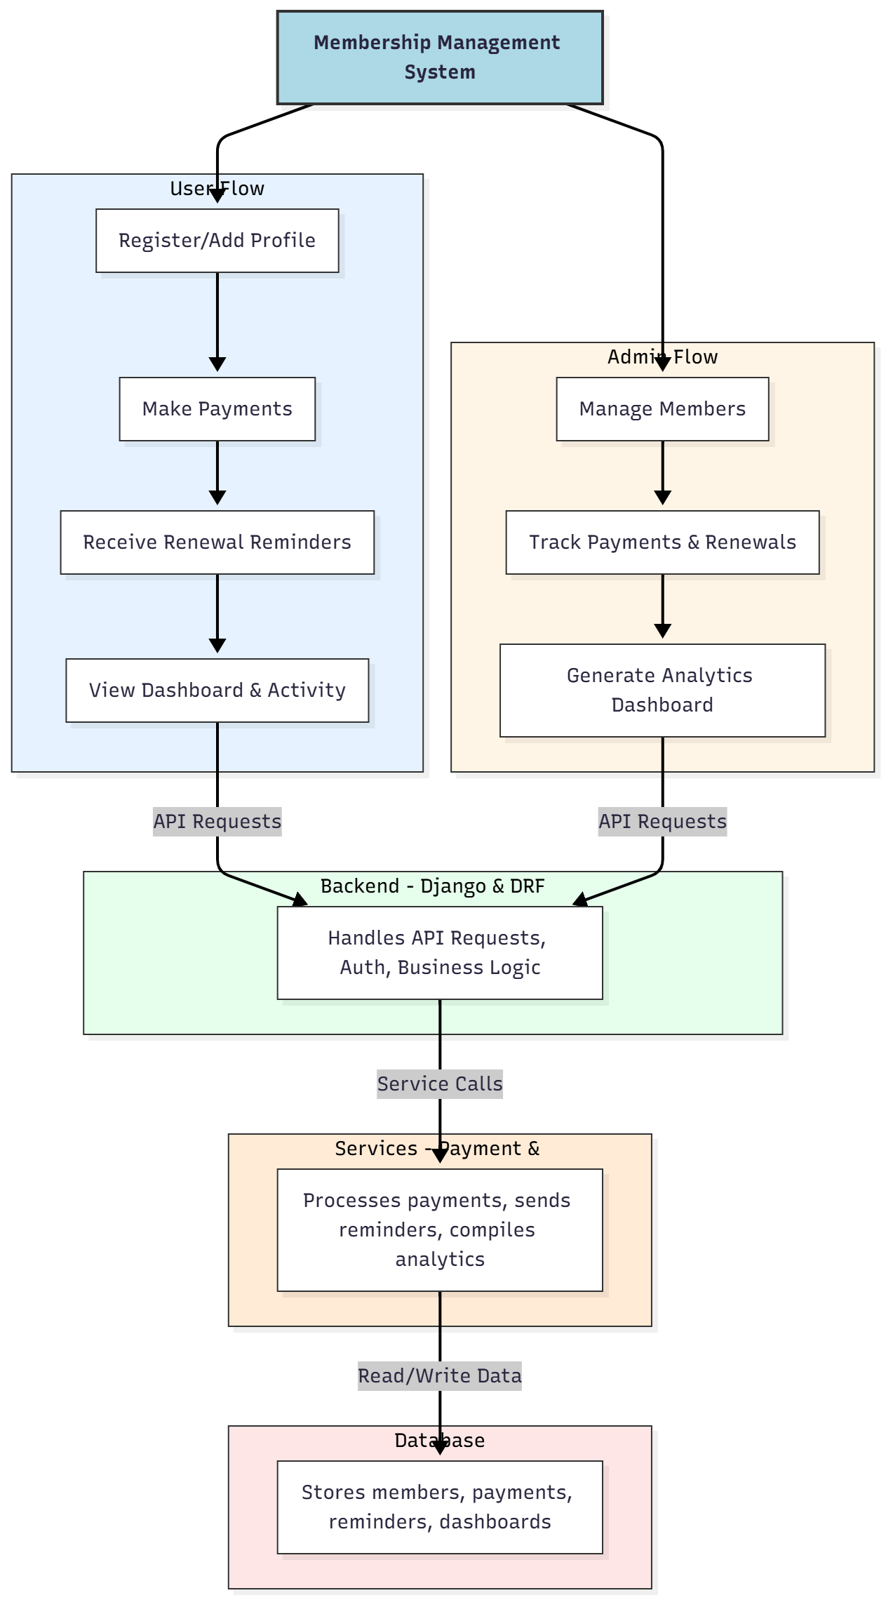

WORKING OF THE PROJECT:
Users register or add profiles, make payments, receive renewal reminders, and monitor membership activity via dashboards. Administrators manage member records, track payments and renewals, and generate analytics reports. The backend handles authentication, API requests, and business logic, while services process payments, reminders, and analytics. All information is stored securely in the database for real-time access and reporting..

SOFTWARE REQUIREMENT:
- Backend:
  - Python 3.x
  - Django
  - Django REST Framework
  - SQLite/PostgreSQL
- Frontend:
  - Node.js and npm
  - React.js
  - Axios
- Development Tools:
  - Visual Studio Code
  - Postman (for testing APIs)
  - Git/GitHub (for version control)
- Server/Deployment (Optional):
  - Gunicorn, Nginx, or Heroku/AWS for hosting

ADVANTAGES OF THE PROJECT:

• Centralized membership management
• Automated payment processing and renewal reminders
• Dashboard analytics for users and admins
• Reduced manual errors in membership tracking
• Improved operational efficiency for organizations
• Easy reporting and analytics
• Secure storage of member information
• Scalable for multiple organizations

APPLICATIONS OF THE PROJECT:
• Gym membership management
• Club member tracking
• Organization subscription management
• Fitness center operations
• Sports team membership tracking
• Student club membership systems
• Community group management
• Any membership-based service tracking

REFERENCES:

- Django REST Framework Documentation — Django Software Foundation. Django Documentation. Available: https://docs.djangoproject.com/
- Django REST Framework. DRF Documentation. Available: https://www.django-rest-framework.org/
- React. React Official Documentation. Available: https://reactjs.org/docs/getting-started.html
- Redux. Redux Documentation. Available: https://redux.js.org/introduction/getting-started
- PostgreSQL Global Development Group. PostgreSQL Documentation. Available: https://www.postgresql.org/docs/
- MySQL. MySQL Reference Manual. Available: https://dev.mysql.com/doc/
- Git. Git Documentation. Available: https://git-scm.com/doc
- Node.js. Node.js Documentation. Available: https://nodejs.org/en/docs/
- Axios. Axios Documentation. Available: https://axios-http.com/docs/intro
- Socket.io Documentation – https://socket.io/docs/

